Anthony Cunningham

Experimental Design & Analysis

3/26/18

**Homework 6 R Code and Output**

1)

surfaceFinish <- read.table("http://www.stat.uiowa.edu/~ernli/DOEdata/problem0509.txt", header=TRUE)

library(car)

surfaceFinishlm = lm(Surface ~ factor(Feed)*factor(Depth), surfaceFinish)

Anova(surfaceFinishlm, type=2)

Anova Table (Type II tests)

Response: Surface

Sum Sq Df F value Pr(>F)

factor(Feed) 3160.50 2 55.0184 1.086e-09 ***

factor(Depth) 2125.11 3 24.6628 1.652e-07 ***

factor(Feed):factor(Depth) 557.06 6 3.2324 0.01797 *

Residuals 689.33 24

par(mfrow=c(2,2))

plot(aov(surfaceFinishlm))

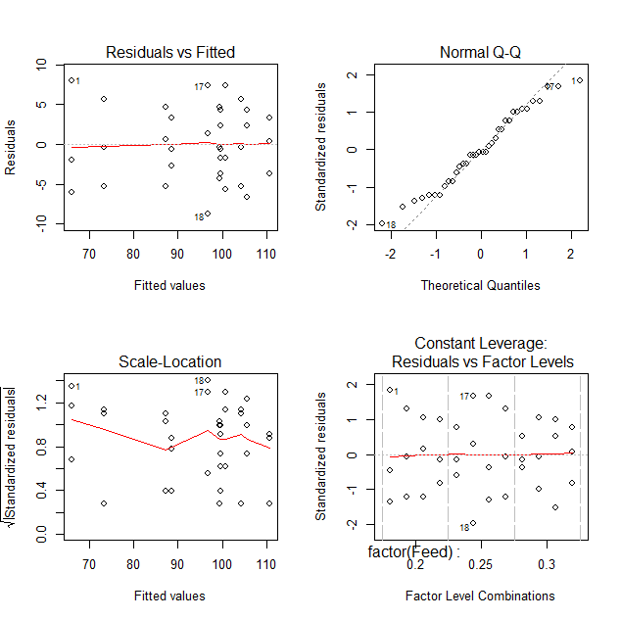

with(surfaceFinish, interaction.plot(Depth, Feed, Surface, type="b"))

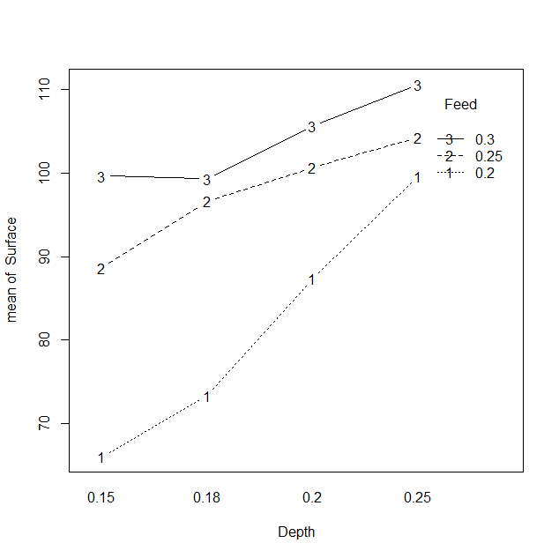

qt.val = qtukey(0.95, 3, 24)

SE.diff = sqrt((2*(689.33/24))/3)

( HSD = (qt.val/sqrt(2))*SE.diff )

[1] 10.92775

TukeyHSD(aov(surfaceFinishlm))

$`factor(Feed):factor(Depth)`

diff lwr upr p adj

0.25:0.15-0.2:0.15 22.6666667 6.8889389 38.4443944 0.0012723

0.3:0.15-0.2:0.15 33.6666667 17.8889389 49.4443944 0.0000035

0.3:0.15-0.25:0.15 11.0000000 -4.7777277 26.7777277 0.3773797

0.25:0.25-0.2:0.25 4.6666667 -11.1110611 20.4443944 0.9935407

0.3:0.25-0.2:0.25 11.0000000 -4.7777277 26.7777277 0.3773797

0.3:0.25-0.25:0.25 6.3333333 -9.4443944 22.1110611 0.9410768

> qt.val = qtukey(0.95, 4, 24)

> SE.diff = sqrt((2*(689.33/24))/3)

> ( HSD = (qt.val/sqrt(2))*SE.diff )

[1] 12.07126

0.3:0.18-0.3:0.15 -0.3333333 -16.1110611 15.4443944 1.0000000

0.3:0.2-0.3:0.15 6.0000000 -9.7777277 21.7777277 0.9585056

0.3:0.25-0.3:0.15 11.0000000 -4.7777277 26.7777277 0.3773797

0.3:0.2-0.3:0.18 6.3333333 -9.4443944 22.1110611 0.9410768

0.3:0.25-0.3:0.18 11.3333333 -4.4443944 27.1110611 0.3371703

0.3:0.25-0.3:0.2 5.0000000 -10.7777277 20.7777277 0.9888577

ybars = c(84.77778, 89.77778, 97.88889, 104.88889)

d = 4

f = 3

n = 3

MSE = 28.7

df.num = d - 1

df.den = d*f*(n - 1)

alpha = 0.05

( ncp = f*n*sum((ybars - mean(ybars))^2)/MSE ) [1] 98.72756

[1] 74.04567

( Fcritical = qf(alpha, df.num, df.den, lower.tail = FALSE) )

[1] 3.008787

( power = 1 - pf(Fcritical, df.num, df.den, ncp) )

[1] 0.9999999

> n = 4

> D = 8

> ncp = f*n*D^2/(2*MSE)

> ( power = 1 - pf(Fcritical, df.num, df.den, ncp) )

[1] 0.8174797

> n = 5

> D = 8

> ncp = f*n*D^2/(2*MSE)

> ( power = 1 - pf(Fcritical, df.num, df.den, ncp) )

[1] 0.9001144

2)

brightness <- read.table("http://www.stat.uiowa.edu/~ernli/DOEdata/problem0511.txt", header=TRUE)

brightnessLM = lm(Current ~ factor(Glass) * factor(Phosphorous), brightness)

summary(aov(brightnessLM))

Df Sum Sq Mean Sq F value Pr(>F)

factor(Glass) 1 14450 14450 273.789 1.26e-09 ***

factor(Phosphorous) 2 933 467 8.842 0.00436 **

factor(Glass):factor(Phosphorous) 2 133 67 1.263 0.31780

Residuals 12 633 53

with(brightness, interaction.plot(Glass, Phosphorous, Current, type="b"))

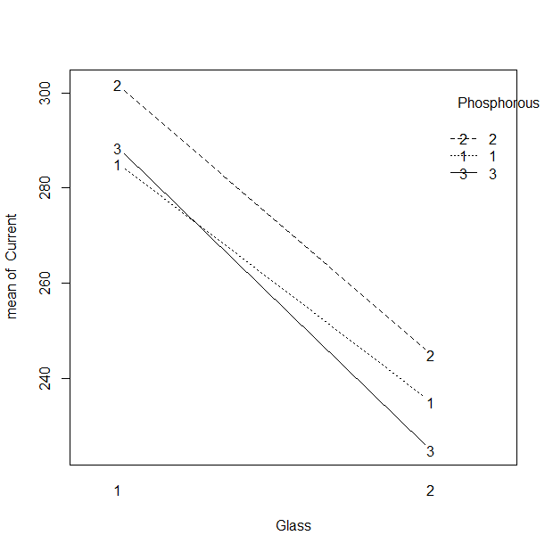

brightnessAdditive = lm(Current ~ factor(Glass) + factor(Phosphorous), brightness)

summary(aov(brightnessAdditive))

Df Sum Sq Mean Sq F value Pr(>F)

factor(Glass) 1 14450 14450 263.870 1.77e-10 ***

factor(Phosphorous) 2 933 467 8.522 0.00379 **

Residuals 14 767 55

TukeyHSD(aov(brightnessAdditive))

Tukey multiple comparisons of means

95% family-wise confidence level

Fit: aov(formula = brightnessAdditive)

$`factor(Phosphorous)`

diff lwr upr p adj

2-1 13.333333 2.151091 24.515576 0.0192911

3-1 -3.333333 -14.515576 7.848909 0.7208313

3-2 -16.666667 -27.848909 -5.484424 0.0042654

3)

tapeStrength <- read.table("http://www.stat.uiowa.edu/~ernli/DOEdata/problem0521.txt", header=TRUE)

tapeStrengthLM = lm(Strength ~ factor(Pressure) + factor(Temperature), tapeStrength)

summary(aov(tapeStrengthLM))

Df Sum Sq Mean Sq F value Pr(>F)

factor(Pressure) 3 0.581 0.1936 0.539 0.6727

factor(Temperature) 2 4.658 2.3288 6.487 0.0316 *

Residuals 6 2.154 0.3590

nonadd = predict(tapeStrengthLM)^2

anova(update(tapeStrengthLM, .~. + nonadd))

Analysis of Variance Table

Response: Strength

Df Sum Sq Mean Sq F value Pr(>F)

factor(Pressure) 3 0.5807 0.19356 0.5815 0.65236

factor(Temperature) 2 4.6576 2.32882 6.9959 0.03556 *

nonadd 1 0.4895 0.48947 1.4704 0.27944

Residuals 5 1.6644 0.33288

with(tapeStrength, interaction.plot(Temperature, Pressure, Strength, type="b"))

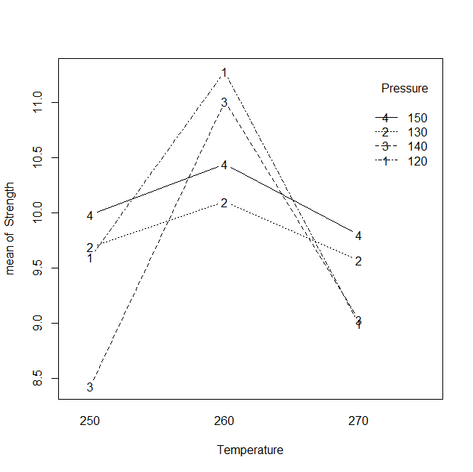

par(mfrow = c(2,2))

plot(aov(tapeStrengthLM, tapeStrength))

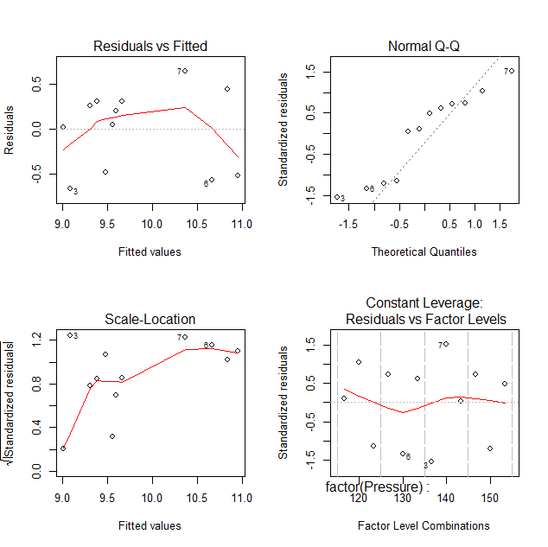

TukeyHSD(aov(tapeStrengthLM))

Tukey multiple comparisons of means

95% family-wise confidence level

Fit: aov(formula = tapeStrengthLM)

$`factor(Pressure)`

diff lwr upr p adj

130-120 -0.1733333 -1.866816 1.520149 0.9833176

140-120 -0.4700000 -2.163482 1.223482 0.7755419

150-120 0.1133333 -1.580149 1.806816 0.9951491

140-130 -0.2966667 -1.990149 1.396816 0.9263837

150-130 0.2866667 -1.406816 1.980149 0.9327449

150-140 0.5833333 -1.110149 2.276816 0.6527757

$`factor(Temperature)`

diff lwr upr p adj

260-250 1.2825 -0.01741413 2.58241413 0.0526001

270-250 -0.0750 -1.37491413 1.22491413 0.9829207

270-260 -1.3575 -2.65741413 -0.05758587 0.0423378

4)

paperStrength <- read.table("http://www.stat.uiowa.edu/~ernli/DOEdata/problem0523.txt", header=TRUE)

paperStrengthLM = lm(Strength ~ factor(Hardwood)*factor(Pressure)*factor(Cooking), paperStrength)

summary(aov(paperStrengthLM))

Df Sum Sq Mean Sq F value

factor(Hardwood) 2 7.764 3.882 10.619

factor(Pressure) 2 19.374 9.687 26.499

factor(Cooking) 1 20.250 20.250 55.395

factor(Hardwood):factor(Pressure) 4 6.091 1.523 4.166

factor(Hardwood):factor(Cooking) 2 2.082 1.041 2.847

factor(Pressure):factor(Cooking) 2 2.195 1.097 3.002

factor(Hardwood):factor(Pressure):factor(Cooking) 4 1.973 0.493 1.350

Residuals 18 6.580 0.366

Pr(>F)

factor(Hardwood) 0.0009 ***

factor(Pressure) 4.33e-06 ***

factor(Cooking) 6.75e-07 ***

factor(Hardwood):factor(Pressure) 0.0146 *

factor(Hardwood):factor(Cooking) 0.0843 .

factor(Pressure):factor(Cooking) 0.0750 .

factor(Hardwood):factor(Pressure):factor(Cooking) 0.2903

Residuals

par(mfrow = c(2,2))

plot(aov(paperStrengthLM, paperStrength))

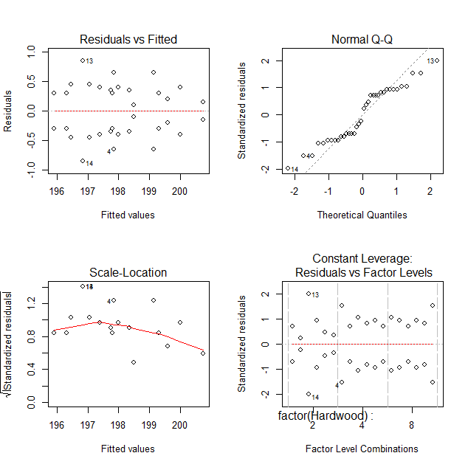

par(mfrow = c(1,2))

with(paperStrength, interaction.plot(Hardwood, Cooking, Strength, type="b"))

with(paperStrength, interaction.plot(Cooking, Hardwood, Strength, type="b"))

